

**————————————————————**

*Methods in spatial analysis*

**————————————————————**

Lecturer： Scholz, Johannes

Stu-Name： Chen, Yuzhou

Stu-number： s1104123

Major： Applied Geoinformatics

Winter semester, 2023

# Introduction

Terrain analysis involves the process of analyzing land-surface features and simulations utilizing terrain data, sometimes named Digital Terrain Analysis (DTA). It encompasses the identification of terrain characteristics, extraction of specific terrain factors, and construction of terrain models. The task of this assignment is to apply some main techniques in terrain analysis to analyze Salzburg and its terrain factors by ArcGIS Pro on the basis of multiple terrain datasets.

# Base Data

All the datasets are as follows:

1. **Base DEM,** digital terrain model of Salzburg, with 5m spatial resolution, generated from airborne laser scan data.
2. **Hydro Catchments,** in the type of shapefile, showing the spatial distribution of all the catchment area within the Salzburg State, which is hosted by Z_GIS organization.
3. **Self-defined research polygon,** which can be selected from the attribute table of hydro catchments using SQL expression, locating a single catchment area of a river for test.

# Task 1: Find suitable catchment area and do visualizations

## Analysis

This task aims to select a suitable catchment area from a large quantity of catchments in Salzburg as my area of interest for all the following tasks and do some basic visualization and symbolization work on the DEM. In order to find eligible results, *Select by attributes*, *Extract by mask*, *hillshade* and *symbology* tools should be used.

## Methods & Results

1. Use *Select by attributes* to select catchment area in the “Gewaesser-Einzugsgebiete” layer where the attribute “HZB_Code” contains “2 8272171 34 *” (Exp. 1). The selected catchment, locating in the southern part of Salzburg and having an area similar to the provided sample area, is determined by checking the distribution of the hydro system in the given DEM. Then, keep the selection, right-click on the layer and choose *Export Features* to export the selected data, and name it *catchment*.

***Where*** *HZB_CODE* ***contains the text*** *“2 8272171 34 *” (1)*

|  |  |
| --- | --- |
|  |  |

1. Then, use *Extract by mask* to extract the DEM of the selected catchment area. Set the *dgm5m* as Input raster, *catchment* as Feature mask data, with an Output raster named *catchment_raster*, which can be used for further analysis.

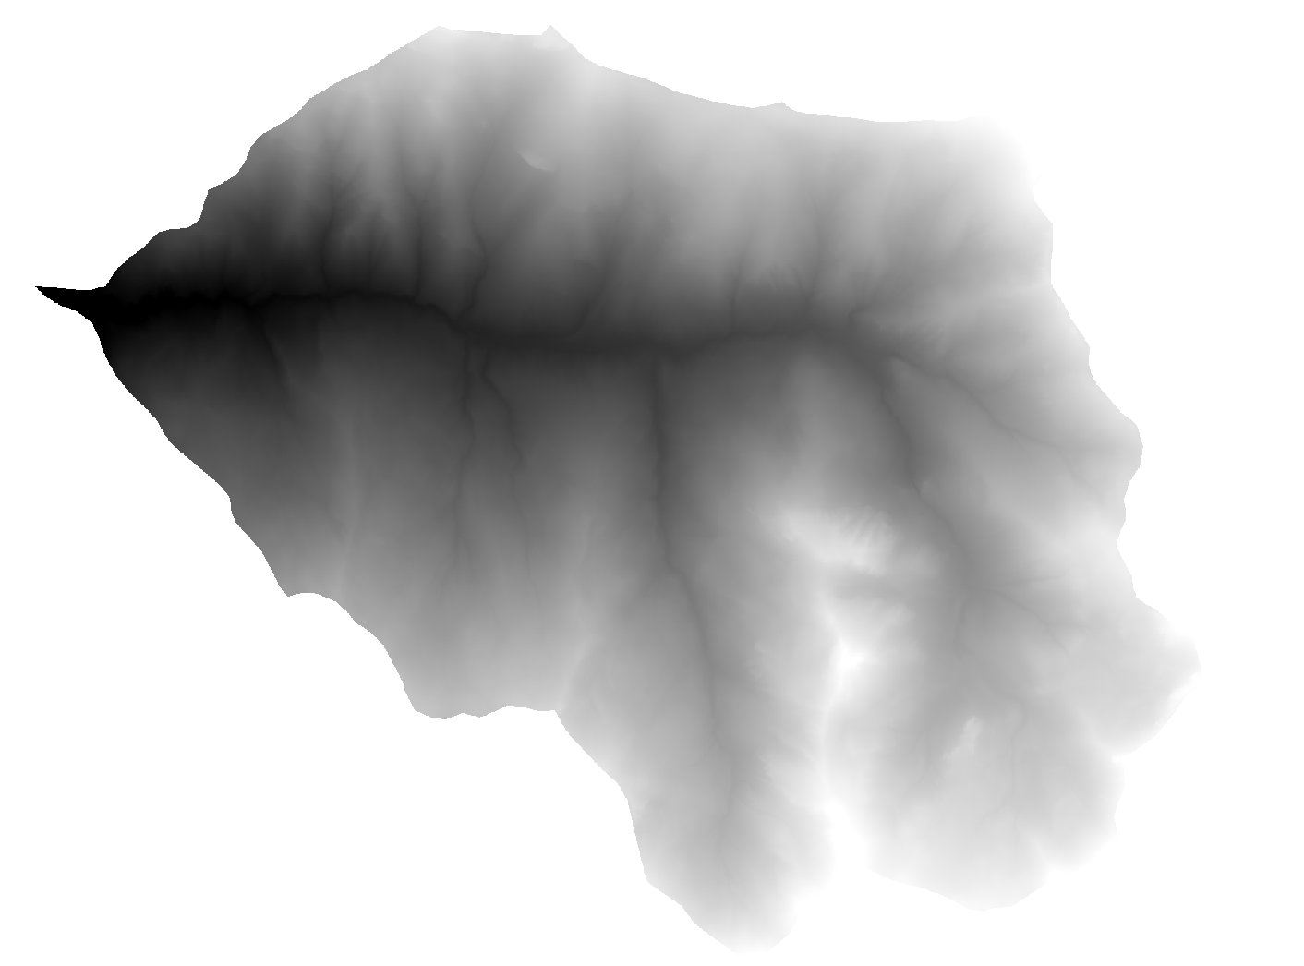

1. Then, use *hillshade* tool to generate the hill shade of the selected catchment area, with an Azimuth of *315* (coming from the due North-West) and an Altitude of *45*, the result can help observers better understand terrain features. At the same time, right-click on *catchment* layer and choose *symbology*, change the color scheme to better depict the elevation of the area. With the help of *Layout,* a whole map was created for all the results of this task.



1. **Analyze the selected region.** The chosen catchment is located in the south-central part of Salzburg, covering an area of about 28.93 km2, with a minimum elevation of 879 m and a maximum of 2261 m, showing a large overall difference in elevation. The rivers inside are located in the north-west, with numerous small tributaries.

# Task 2: Calculate a map of slope and aspect

## Analysis

This task aims to calculate the slope and aspect factors indicating the topology of the selected catchment and build a histogram based on it. To calculate the results, *Slope, Aspect* and *Create chart* tools need be used.

## Methods & Results

1. Use *Slope* and *Aspect* tools to calculate the distribution of slope and aspect within the current catchment, respectively. In *Slope* tool, set *catchment_raster* as the Input raster, *Degree* as the Output measurement, and *Planar* that is often used for geo-data with a projected coordinate system as the Method, with an Output named *slope*. The *Aspect* tool has the same input data as *Slope*, with an Output named *aspect*.

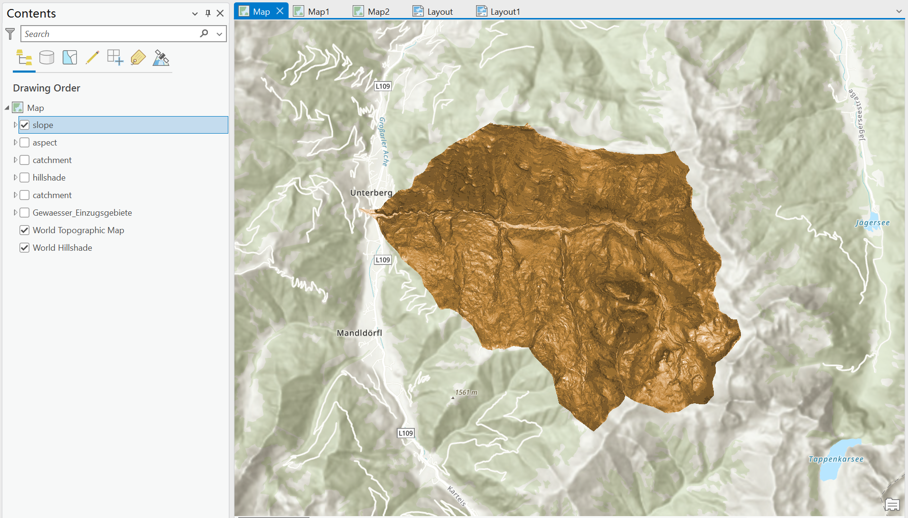

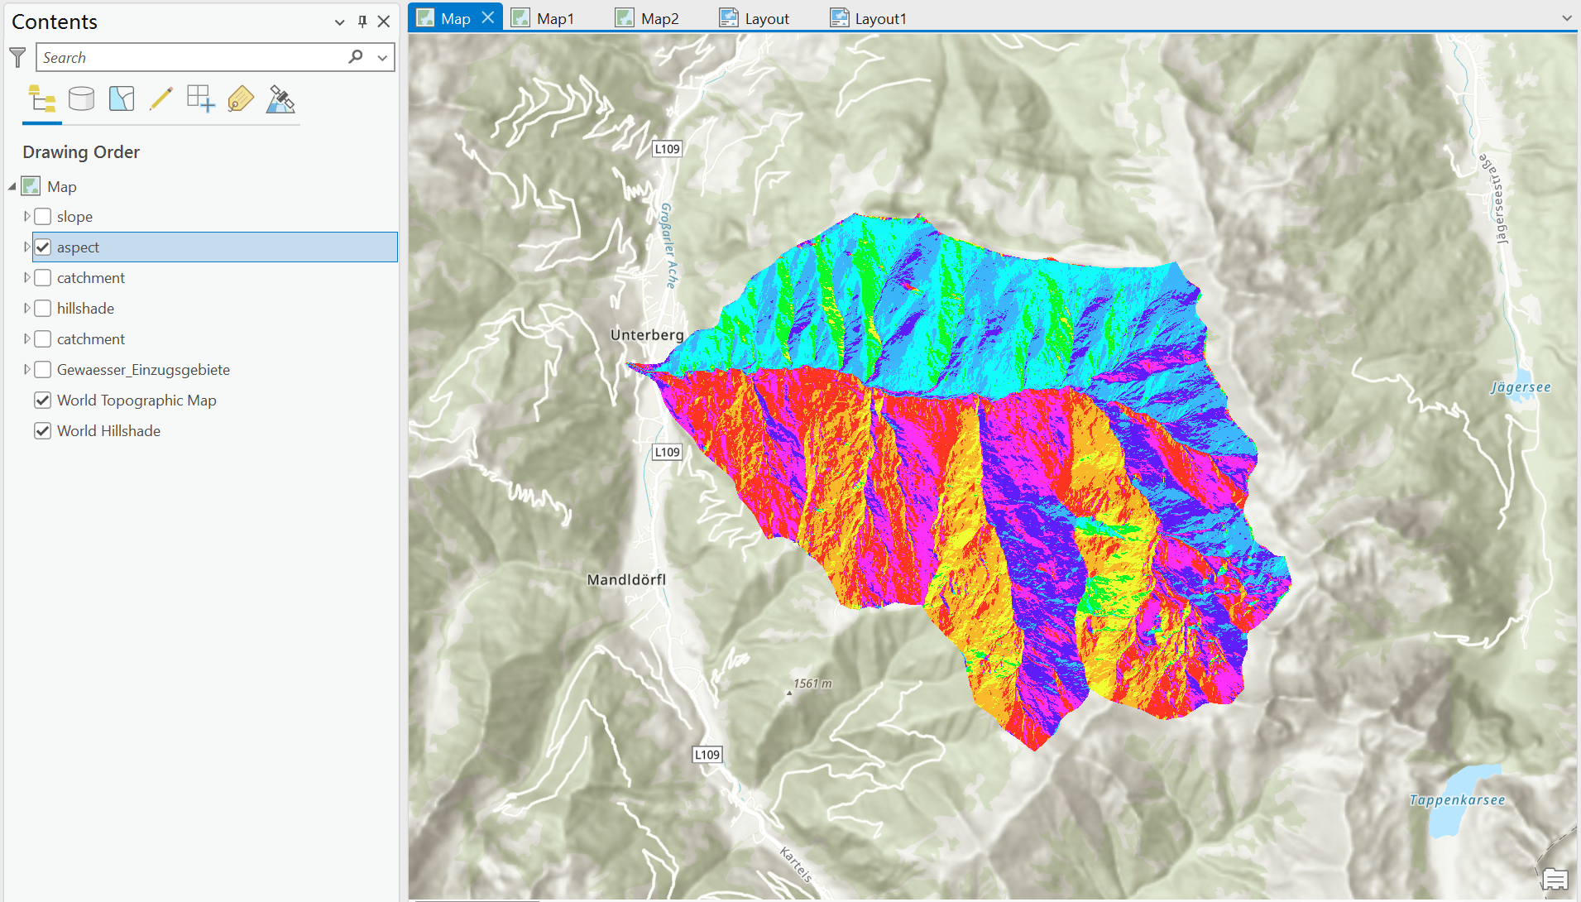

1. Then, use *Create chart* to calculate the average slope. Right-click on the *slope* layer, choose [Create chart]->[Histogram] and do basic settings on the histogram: 1) Define *Band_1* as the Number; 2) Set the number of Bins to 32; 3) Tick the checkbox *Mean* in Statistics. A slope histogram will be generated after that. Actually, there are other 2 ways of calculating the average, one is in the layer [Properties]->[Source] ->[Statistics], where *Mean* being displayed, another is *Zonal_Statistics* tool, which will be mentioned below.

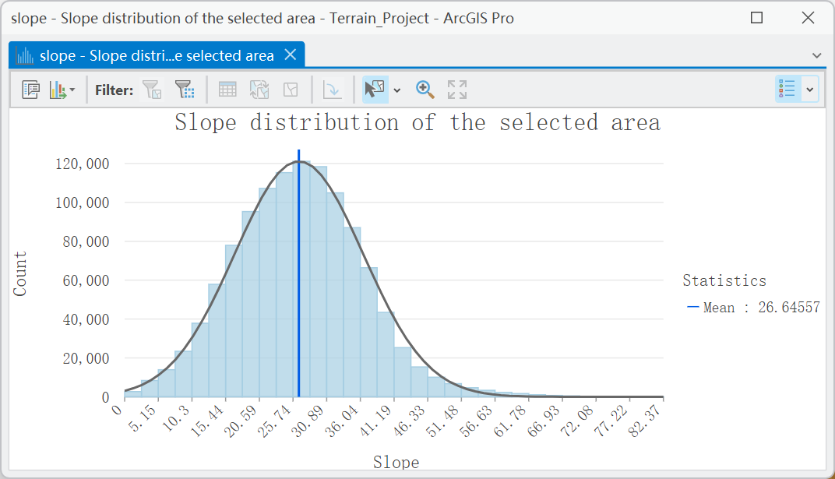

1. **Try to analyze the result.**

Firstly, the above histogram named *Slope Distribution* depicts the frequency of grids with different slope values in the study area using 5.15° as the grading threshold and counts the average slope in the region.

It is worth noting that the average slope of the experimental area is about 26.65°, which implies that the overall slope in the region is higher and distributed with steeper hills. Moreover, the frequency of slope grids from 23° to 31° is the highest, covering a large part of the whole region.

If the slopes in the region are classified with the average slope as the boundary, and the slope grid exceeding 26.65° are labelled as RGB(255,170,0), it is found that the areas higher than the average of the slopes are mainly distributed along the rivers and near the ridges, and that the slopes in the Northern part of the region are significantly higher than those in the Southern part of the region.

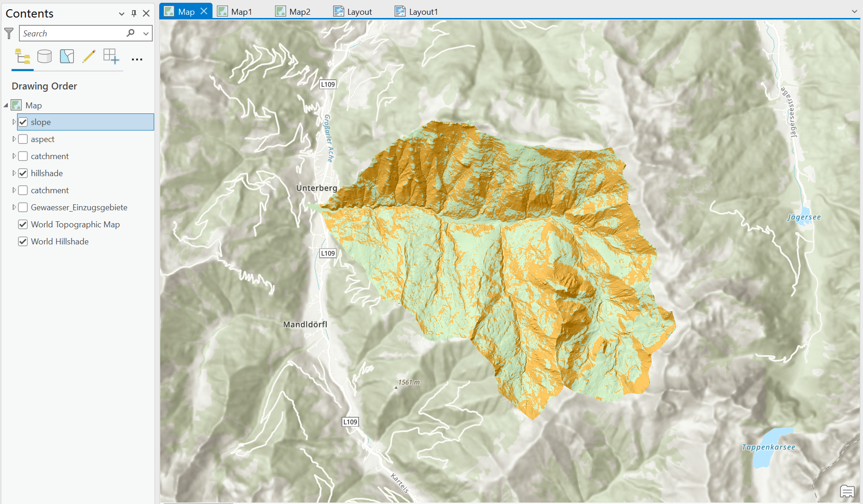

Additionally, considering the probability density distribution presented by Normal Dist., the frequencies of all levels of slopes conformed to a normal distribution, but showed a slight right skewed (positively skewed distribution).

# Task 3: Calculate average slope inside elevation zone

## Analysis

This task aims to calculate the average slope within each elevation zone parted by suitable elevation intervals. To calculate the eligible results, *Contour*, *Zonal_Statistics, Extract by Mask* and *Model Builder* need be used.

## Methods & Results

1. Given that the *slope* layer has been created before, what we need to do first is calculating the contours. Use *Contour* to generate the parted elevation zone, with a fixed contour interval of *200m*, and choose *Contour polygon* as the contour type to directly output polygon (which is closed) instead of lines. The output named *contour* is as follows.

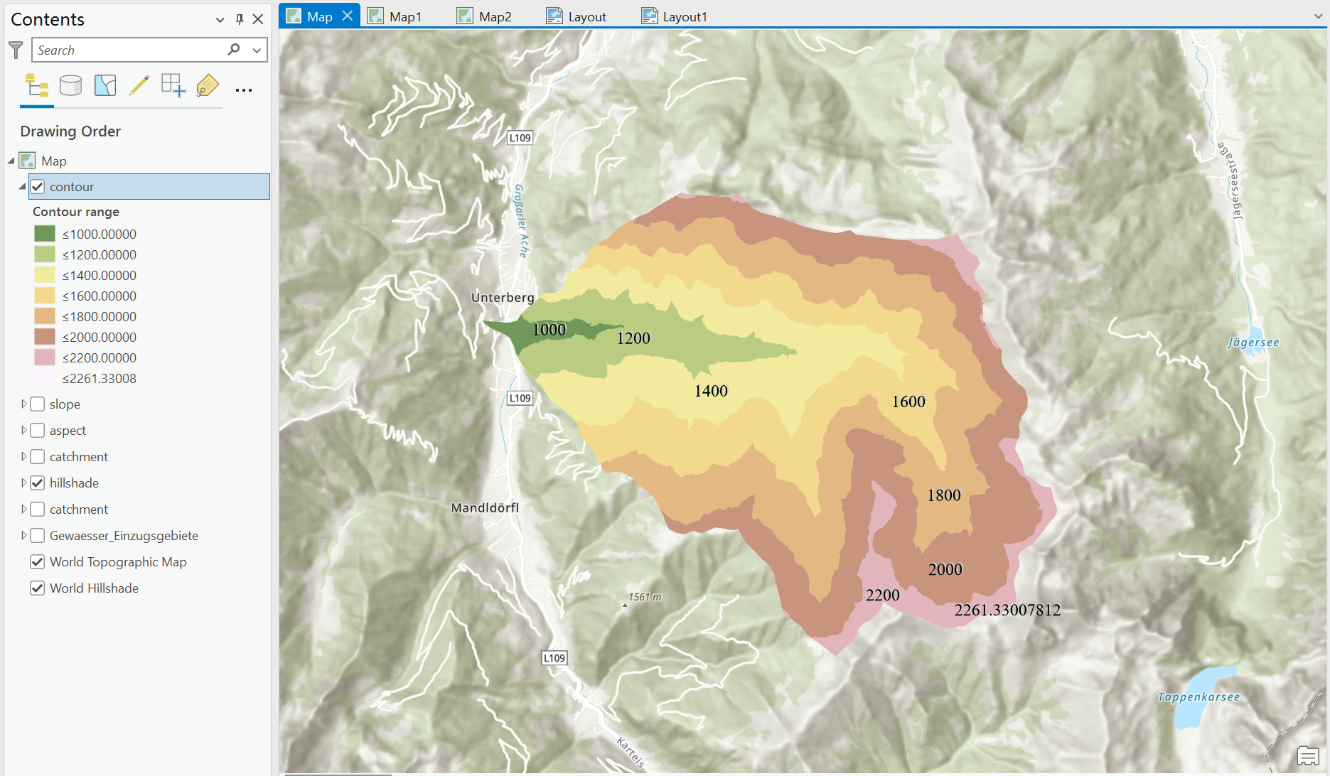

1. Then, use *Zonal_Statistics* to calculate the average slope for each elevation zone, where Feature Zone Data is *contour* and Statistics Type is *Mean*. To avoid using default *FID* as Zone Field Value, I add a field named *Id* for *contour*, which can act as an identifier of zones in Statistics. To better symbolize the result, open the symbology window and choose *Unique Values*, so that raster values can turn into discrete values instead of continuous values, which can be easier to classify. The result is as follows:

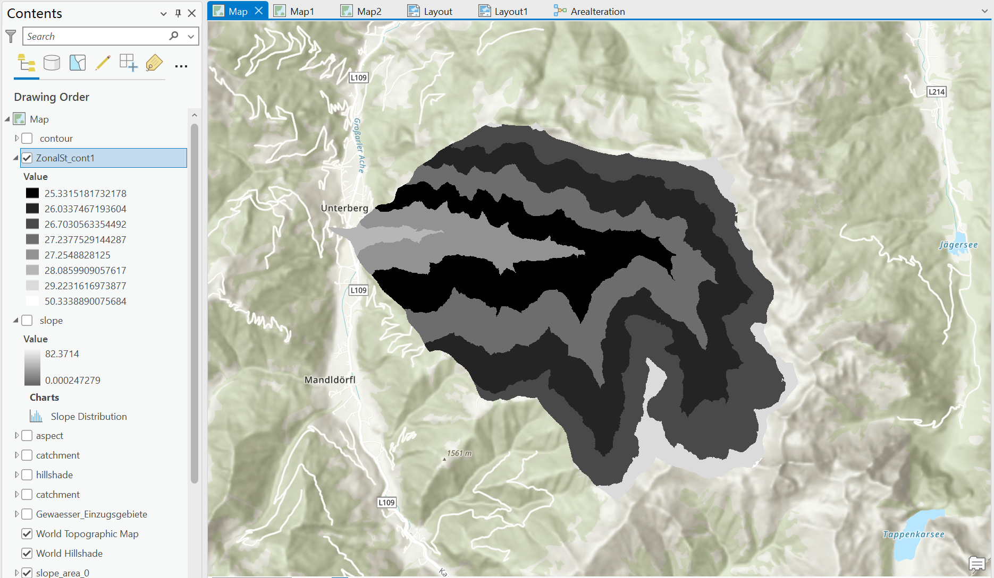

1. Provide the slope histograms in each elevation zone. First, a new *Model* is needed to iterate through all the elevation zones as masks to extract the *slope* raster data. Then, histograms can be built based on the slope attribution in each zone. The model builder workflow and slope histograms are shown as follows:

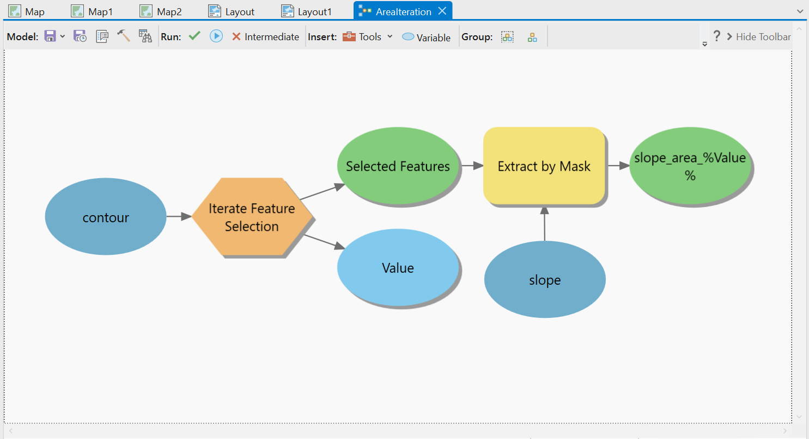

|  |  |
| --- | --- |
|  |  |
|  |  |
|  |  |
|  |  |

1. **Try to analyze the result.**

Most importantly, the average slope values obtained from the histogram of all the areas in Step3 coincide with the calculation results of Step2, and therefore can corroborate the correctness of the Step2 method.

Considering that the elevation of this catchment increases gradually from west to east, I compare the elevation distribution with the average results of Step2 and conclude that the correlation coefficients between the elevation and slope factors are small in this catchment. This is because in some areas of low elevation, there are also regions with higher slope; and vice versa. Overall, the areas with the minimum average slope in this catchment are located in the middle reaches of the river, while areas with higher slopes are found in the upper and lower reaches of the river.

Observing the histograms of the slope distribution of each area obtained by Step3, it is found that the slopes are basically in line with the normal distribution. The number of raster in each area varies greatly, and the statistical value of the average slope is skewed for areas with a smaller number of rasters. In addition, except for area7, which has a small sample size, the difference in mean slope for all the areas is a maximum of 4°. The slopes in most of the areas showed negative skewed distribution.

# Task 4: Scale effect on slope calculation

## Analysis

This task aims to calculate the slope factor based on various resolution DEMs of the selected catchment area and measure the scale effect accordingly. To calculate the results, *Resample*, *Model Builder, Slope* and *Zonal Statistics* tools need be used.

## Methods & Results

1. Resample the 5m resolution *catchment* to 10m and 100m. Apart from *Resample* tool, using [Data]->[Export Raster] is an easier way to reset the resolution. The results are named *catchment10m* and *catchment100m*, respectively. It’s hard to tell the difference between the DEM in 5m and 10m unless I zoom in, while changes in 100m resolution can be easily observed.

|  |  |
| --- | --- |
|  |  |
| catchment10m | catchment100m |

1. Use *Model Builder* to create a workflow to iterate through DEM in all resolution of 5m, 10m and 100m. In my workflow, *Contour* tool is used to calculate the contour polygon, *Slope* is used to calculate the slope value and *Zonal Statistics* is for providing the average slope for each elevation zone. Use the Iterator named “Iterate Rasters”, choose the “Terrain_Project.gdb” as Workspace and set *“ catchment* ”* as the Wildcard, so that all 3 DEM can be considered in the model. The divided contour areas and zonal average slope results are shown in maps as follow.

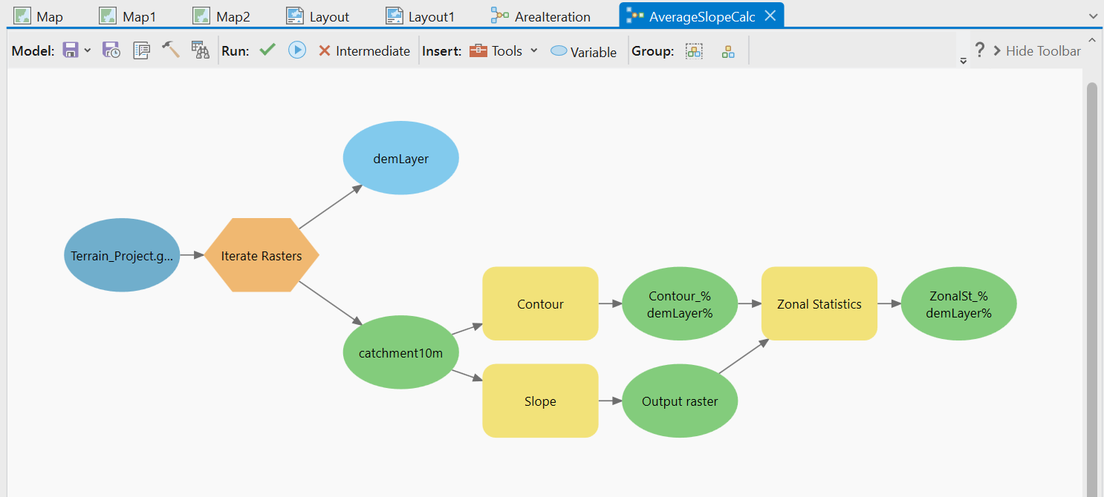

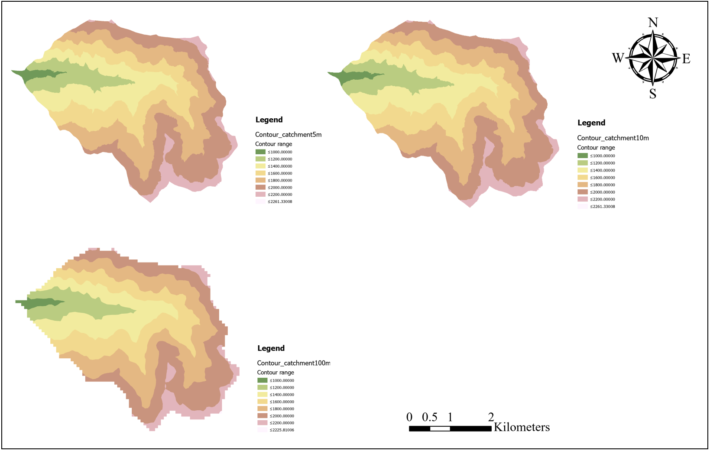

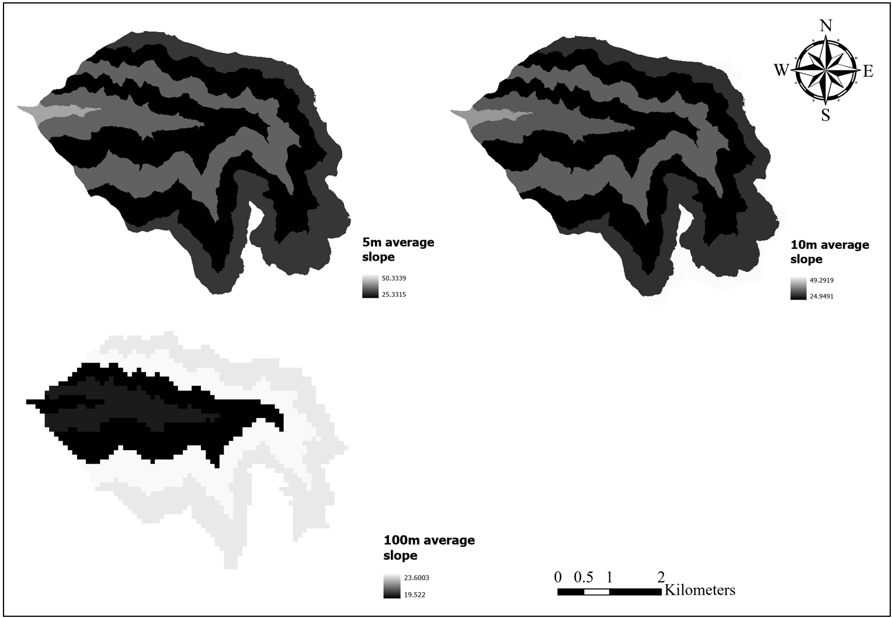

1. Use *Create chart* to draw the histogram of slope attribution with different resolution.

|  |  |
| --- | --- |
|  |  |

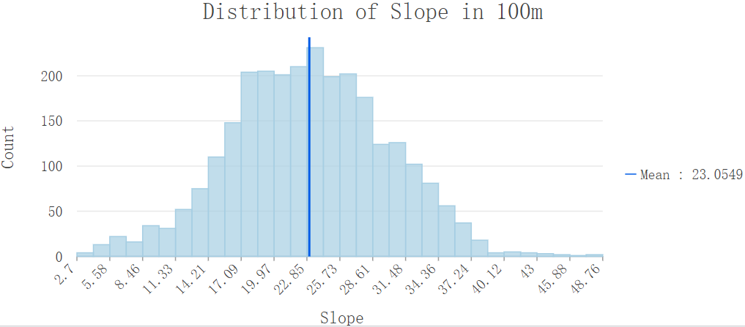

1. **Try to analyze the result.**

Firstly, it is worth noting that the mean value of the slope in the same area calculated by the 10m resolution DEM is smaller than the result at 5m resolution, but in general the change is not significant. However, once the DEM resolution is reduced to 100m, then the calculated slope results change dramatically. Within this study area, the mean value of slope then decreased from 26.64° at 5m resolution to 23° at 100m resolution.

Upon study, I concluded that the above results are due to the scale effect of terrain statistics. In this task, I reduced the resolution of the DEM by resampling it, which means erasing some of the terrain details, resulting in the overall undulation of the region becoming smaller, and the calculated slope results will naturally become smaller (Tang *et al.*,2001).

There are also research works on selecting the appropriate DEM resolution and Analysis Window size for the topographic features of the region to weaken the DEM scale effect.

# References

Guo-an, T., Strobl, J., Jian-ya, G., Mu-dan, Z., & Zhen-Jiang, C. (2001). Evaluation on the accuracy of digital elevation models. *Journal of Geographical Sciences*, *11*, 209-216.